Heap Data Structure

**What is Heap Data Structure?**

*A Heap is a special Tree-based data structure in which the tree is a complete binary tree.*

**Operations of Heap Data Structure:**

* **Heapify:** a process of creating a heap from an array.
* **Insertion:** process to insert an element in existing heap time complexity O(log N).
* **Deletion:** deleting the top element of the heap or the highest priority element, and then organizing the heap and returning the element with time complexity O(log N).
* **Peek:** to check or find the most prior element in the heap, (max or min element for max and min heap).

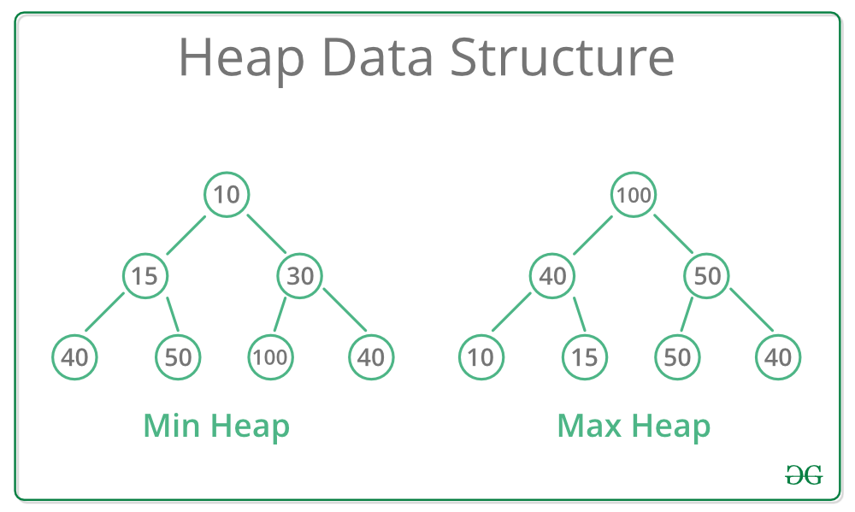

**Types of Heap Data Structure**

Generally, Heaps can be of two types:

1. **Max-Heap**: In a Max-Heap the key present at the root node must be greatest among the keys present at all of it’s children.
2. The same property must be recursively true for all sub-trees in that Binary Tree.
3. **Min-Heap**: In a Min-Heap the key present at the root node must be minimum among the keys present at all of it’s children.
4. The same property must be recursively true for all sub-trees in that Binary Tree.